PROJECT OVERVIEW
This project involves discovering the characteristics that enables a business to stand the test of time.
To help answer this question, BusinessFinancing.co.uk researched the oldest company still in business in almost every country and compiled the results into several CSV files. This dataset has been cleaned.

The Data
businesses table and new_businesses table
Column | Description
business | Name of the business (varchar)
year_founded | Year the business was founded (int)
category_code | Code for the business category (varchar)
country_code | ISO 3166-1 three-letter country code (char)

countries table
Column | Description
country_code | ISO 3166-1 three-letter country code (varchar)
country | Name of the country (varchar)
continent | Name of the continent the country exists in (varchar)

categories table
Column | Description
category_code | Code for the business category (varchar)
category | Description of the business category (varchar)

We will understand the factors that help a business be timeless by answering these questions:
- What is the oldest business on each continent?
QUERY:

SELECT
CT.continent,
CT.country,
AB.business,
AB.year_founded
FROM all_businesses AS AB
JOIN countries AS CT
ON AB.country_code = CT.country_code
JOIN (
SELECT
CT.continent,
MIN(AB.year_founded) AS Earliest_Business_Year
FROM all_businesses AS AB
JOIN countries AS CT
ON AB.country_code = CT.country_code
GROUP BY CT.continent
) AS SubQ
ON CT.continent = SubQ.continent AND AB.year_founded = SubQ.Earliest_Business_Year;
RESULT:
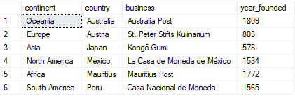

- How many countries per continent lack data on the oldest businesses?

QUERY:

SELECT
CT.continent,
COUNT(CT.country_code) AS countries_without_businesses
FROM countries AS CT
LEFT JOIN all_businesses AS AB
ON CT.country_code = AB.country_code
WHERE AB.country_code IS NULL
GROUP BY CT.continent;
RESULT:
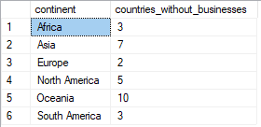

- Which business categories are best suited to last many years, and on what continent are they?
QUERY:

SELECT
c.continent,
cat.category,
MIN(b.year_founded) AS year_founded
FROM businesses b
INNER JOIN categories cat
ON b.category_code = cat.category_code
INNER JOIN countries c
ON b.country_code = c.country_code
GROUP BY
c.continent, cat.category
ORDER BY
c.continent, cat.category;

RESULT:

